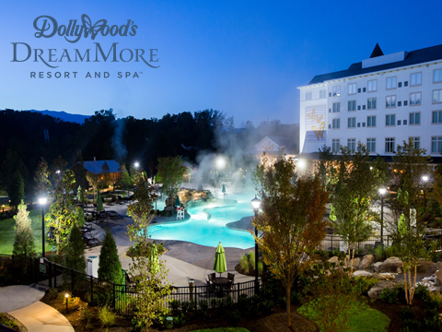
MILES AWAY FROM ORDINARY,
MINUTES AWAY FROM EXCITEMENT

Whether you’re a theme park thrill seeker or a nature lover visiting the Great Smoky Mountains National Park, Dollywood’s DreamMore Resort and Spa™ always makes you feel welcome.
So settle in, reconnect, have fun and share your dreams.

A block of rooms has been reserved September 19-23, 2019 at the special rate of $249.00 plus applicable tax per room, per night based upon availability. We also have a limited number of suites available at a special rates as well. Reservation requests should be made as soon as possible but no later than Sunday, August 18, 2019.

Reservation requests may be made by calling the following number:
800-DOLLYWOOD (800-365-5996) and requesting the Josie Music Awards room block.

When reservations are made, DMR will require a deposit equal to the room rate and tax for the first night for each reservation. An individual’s deposit is refundable to that individual if DMR receives notice of an individual’s cancellation at least three (3) days prior to scheduled arrival.

